Nome: ______________________________________________________ Data: ___ / ___ / 2015

Escrita Criativa

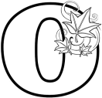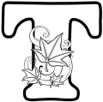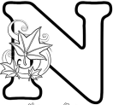

- Quando pensas no outono, de que te lembras?

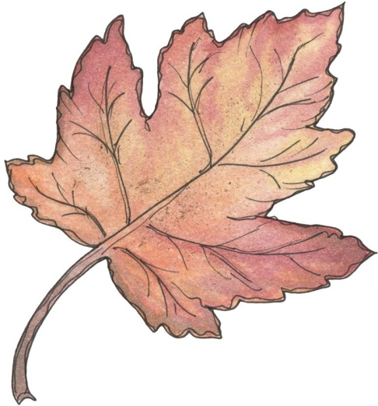
queda das folhas

OUTONO

- Completa.

- O que é? → ________________________________________________________________________
- Como é o tempo? → _________________________________________________________________
________________________________________________________________________________
- Que roupa vestimos? → ______________________________________________________________
________________________________________________________________________________
- Quais os seus frutos? → ______________________________________________________________
________________________________________________________________________________
- O que se comemora? → ______________________________________________________________
________________________________________________________________________________
- Que cores apresenta? → _____________________________________________________________
________________________________________________________________________________
- Outras informações: _________________________________________________________________
________________________________________________________________________________
- Escreve um texto sobre o outono, a partir da informação recolhida.

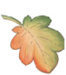
O outono

________________________________________________________________________________________________________________________________________________________________________________________________________________________________________________________________________________________________________________________________________________________________________________________________________________________________________________________________________________________________________________________________________________________________________________________________________________________________________________________________________________________________________________________________________________________________________________________________________________________________________________________________________________________________________________________________________________________________________________________________________________________________________________________________________________________________________________________________________________________________________________________________________________________________________________________________________________________________________________________________________________________________________________________________________________________________________________________________________________________________________________________________________________________________________________________________________________________________________________________________________________________________________________________________________________________________________________________________________________________________________________________________________________________________________________________________________________________________________________________________________________________________________________________________________________________________________________________________________________________________________________________________________________________________________________________________________________________________________________________

