EB1 nº 2 de Chaves
4º Ano
Nome: ________________________________________________
Data: ___________
________

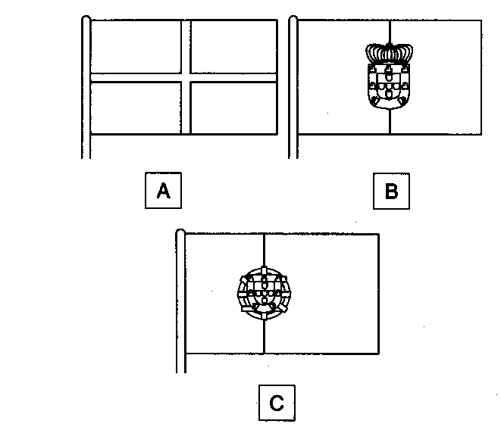 | A - ______________________________  ________________________________  B - ______________________________  ________________________________  C - ______________________________  ________________________________

